Data Mining unit 6- Cluster Analysis

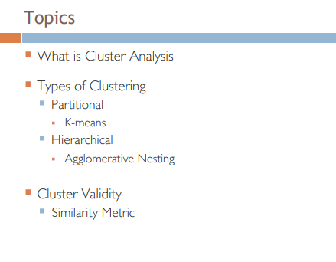

What is Cluster Analysis?
Groups data objects based only on info found in the data that describes the object and its relationships. So that eventually objects within a group should be similar to each other and different from objects in another group.
The more distinct the difference the better the clustering.
Why use cluster analysis?
Because it helps enable data summarisation via reduction in size of large sets of data, and reduces computational cost.
It can also be used as a pre-processing step to fit regression models for homogenous data sets.

Types of Clustering
Partitional – Clustering based on division of data objects into non-overlapping subsets. So that each data object is in one subset exactly.
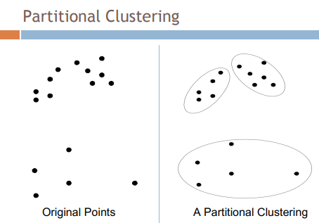
An example of Partitional clustering is K-Means.
K-Means clustering uses a centroid point that groups nearby data points, according to distance. Thus each point will be put into a given cluster based on the closest centroid.
Algorithm:
-Select k number of centroids
- repeat
-Form K clusters by assigning points to nearest centroid
-Recompute centre of each centroid(cluster).
-until centroids don’t change
The initial centroids are random, centroids tend to be the mean/median points in cluster
Closeness done by Euclidian distance
Evaluating K-Means Clusters:
Most commonly done by SSE(Sum-Squared-Errors)
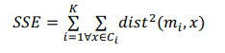
Where x is the data point and mi is the centroid for that cluster. One way to reduce SSE is to increase K, the number of clusters.
Hierarchical – Clustering via nested clusters organised as a hierarchical tree. Clusters can have sub-clusters i.e. a data object can reside within a parent node but also the child node of that parent node. Ergo the data objects belongs in both subsets.
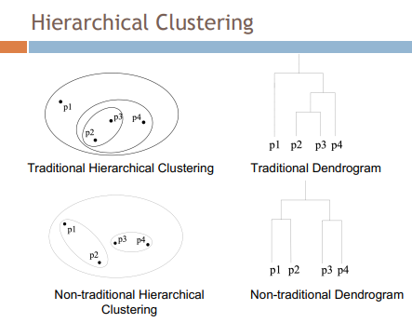

Pre/Post-Processing:
Pre:
-Normalise Data
- Remove Outliers(Extremes)

Post:
- Eliminate small clusters as they may rep outliers
- Split loose clusters with high SSE
- Merge clusters that are close and have low SEE

How to choose K(Number of Clusters?)
Methods for doing so:
Elbow Method = Iteratively increase number of clusters and observe total SSE. SSE tends to become static in increase at a point. Select K with good trade-off between model complexity and SSE
Limitations to K-Means 9(it suffers) when
Clusters differ in sizes, density and non globular shapes or has outliers. To remedy this however, find lots of clusters and merge them.
Hierarchical Clustering:
Produces set of nested clusters organised as a hierarchical tree.
Strengths of Clustering:
Doesn’t need to assume any particular number of clusters like in K-means. Therefore any Desired number of clusters can be made by cutting the dendrogram at proper level.
May correspond to meaningful taxonomies
Types of Hierarchical Clustering:
Agglomerative(bottom-up)
Start with points as individual clusters and iteratively merge the closest pairs until only one cluster remains.
Divisive (Top-Down)
Start with a single cluster and iteratively split them until only a single point resides in each cluster.
Cluster similarity (min or single Linkage)
The idea that the similarity of two clusters are based on a single link, by two cluster points which are similar(closest) to each other.
Cluster similarity MAX or complete Linkage
Concept that the similarity of two clusters are based on the least similar(most distant) between all pairs of points in both clusters.
It’s good as it is not affected by noise or outliers. However, it breaks large clusters and biased towards globular clusters.
Cluster similarity Group Average:
Proximity of two clusters is the average of pairwise proximity between points in two clusters.
Limitations of Hierarchical Clustering:
Once clusters have been merged you cannot unmerge them.
Can be prone to noise and outliers
Difficult to handle diff sized clusters
Breaks large clusters.
Cluster validity:
Checks the measure of accuracy of the clusters in order to :
Avoid finding patterns in noise
Comparing clustering algorithms
Comparing two sets of clusters
Aspects of cluster validation:
Determine Clustering Tendency of a data set to distinguish whether non random structures exist in the data.
Compare results of cluster analysis to externally known results.
Evaluating how well results of cluster analysis fit the data without reference to external info.
Measures of Cluster validity:
External Indices : Used to measure extent in which cluster labels match externally supplied class labels
Internal Indices: Used to measure the goodness of a clustering structure without respect to externally provided info. E.g. SSE
Relative Indices: Used to compare two diff clusters usually with internal or external info.
Cluster separation measures how distinct a cluster is from another using the BSS (between cluster sum of squares).

